|  |  |
| --- | --- |
|  | **FPT ACADEMY INTERNATIONAL**  **FPT – APTECH COMPUTER EDUCATION** |

**Centre Name: ACE-HCMC-2-FPT.**

**Address: 590 Cach Mang Thang 8, District 3, Ho Chi Minh City, Viet Nam.**

**CALLIGRAPHY**

|  |  |  |
| --- | --- | --- |
| **Supervisor.** | **Nguyễn Phát Tài** | |
| **Batch.** | **T1.2011.M0** | |
| **Group.** | **2** | |
| **Serial No.** | **Enrollment Number** | **Student Name** |
| 1. | Student1285594 | Vũ Trọng Phong |
| 2. | Student1287966 | Đỗ Trần Long |
| 3. | Student1281546 | Bùi Đại Thắng |
| 4. | Student1268354 | Lê Thanh Ngọc Bích |

Month 3 Year 2021

**This is to certify that**

**Mr&Mrs.:**

Vũ Trọng Phong______________________

Đỗ Trần Long________________________

Bùi Đại Nghĩa_________________________

_____________Lê Thanh Ngọc Bích____________________

**has successfully designed & developed**

**eProject: Calligraphy website_____________**

**Submitted by: *Do Tran Long***

**Date of issue: 29-Mar-2021**

**Authorized Signature: *Phong***

**TABLE OF CONTENTS**

ACKNOWLEGMENT 3

SYNOSIS 3

PROBLEM DEFINITION 3

CUSTOMER'S REQUIREMENTS SPECIFICATIONS (CRS) 4

Business/Project Objective: 4

Hardware/ Software Requirements: 5

SCOPE OF THE WORK (IN BRIEF) 6

Architecture and design of the system 7

Diagram of the website 8

TASK SHEET REVIEW 1 9

SITE MAP 10

MOCK OF THE WEBSITE 11

1. **HOMEPAGE** 12
2. **CONTACT US** 13
3. **ABOUT US** 14
4. **GALLERY** 15

# **ACKNOWLEGMENT**

On behalf of all the members of group 2, I would like to thank you all for the hard works, supports to make this eProject complete successfully. Especially, Mr. Nguyen Phat Tai, our teacher, he helped us a lot from the day that we started to study at FPT Aptech. With this eProject, he has guided us with his enthusiasm and rigorous, because of him guiding, we would be able to finish this project. Besides, I want to thank all the team member of group 2, each of the team members has been working continuously in 4 weeks in order to complete this project. The last but not least, we would like to say thank you to our family for always supporting us, creating the best conditions for us to focus on the project, and putting faith in the dreams we pursue.

# **SYNOSIS**

Here we are aiming to design a website “QuickCalligraphy” which will provide an easy way to learn calligraphy and provide the basic other details about the art.

# **PROBLEM DEFINITION**

The Web site is to be created based on the following requirements.

1. The home page must describe the keywords or highlight the calligraphy designs with all navigation links defined.
2. The site should provide the brief information about calligraphy as from where it originated etc.
3. There should be a well-designed menu with necessary sub menu options.
4. There should be various categories (forms and styles) like easy for kids, complex for elders and so on
5. There should also be categories of designs as Arabic, Indic, Greek etc(more categories can be added)
6. Proper description of the letters and fonts must be added in the website.
7. Contact us page: contact us details with location should be displayed using GeoLocation API (eg. GoogleMaps).
8. About Us
9. Feedback form
10. Gallery section should be added.
11. Color combination must be uniform throughout the project.
12. Navigation must be smooth.

3

*FPT-APTECH – T1.2011.M0. – Group 2*

*FPT-APTECH – T1.2011.M0. – Group 2*

*FPT-APTECH – T1.2011.M0. – Group 2*

**CUSTOMER'S REQUIREMENTS SPECIFICATIONS (CRS)**

**Client: CALIGRAPHY**

### **Business/Project Objective:**

Calligraphy is a visual art related to writing. It is the design and execution of lettering with a broad-tipped instrument, brush, or other writing instrument. A contemporary calligraphic practice can be defined as "the art of giving form to signs in an expressive, harmonious, and skillful manner". Hence they need to have a website with all their products listed on the website.

A website needs to be designed to display various calligraphy hands lettering with the website. Details of locations using GeoLocation API (eg. GoogleMaps), feedback must be included.

The website is to be developed for the Windows Platform using HTML5, JavaScript and Geolocation. The site should work well in all leading browsers including Chrome, IE, Firefox etc.

**Input to the system:**

* + - * Search calligraphic writing types of countries

**Output from the system:**

* A menu that will categorize all the functions of the site.
* Display the list of available albums category wisely.
* Perform the search based on a particular: Calligraphy type of countries.
* Site should be able to provide brief introduction/history about the showroom under About Us page.
* The location of the showroom under Contact-Us page.
* Besides the above requirements, the site should have look and feel as per the industry standards.

**Expected delivery date:** 11-March-2021.

**List of deliverables:**

* + - * Document Word.
      * User Guide.
      * Source code.

4

*FPT-APTECH – T1.2011.M0. – Group 2*

### **Hardware/ Software Requirements:**

* **For developer**

**Hardware**

* + Intel Pentium 4 processor or higher
  + 1 Gigabytes of RAM or higher

**Software**

* + Windows 7 OS or higher
  + Adobe Dreamweaver
  + Web browsers such as IE, Chrome or Firefox are supporting HTML5, CSS3 and Javascript.
* **For web users**

**Hardware**

* + Intel Pentium 4 processor or higher
  + 512 Megabytes of RAM or higher

**Software**

* + Windows XP OS or higher
  + Web browsers such as IE, Chrome or Firefox are supporting HTML5, CSS3 and Javascript.

5

*FPT-APTECH – T1.2011.M0. – Group 2*

# **SCOPE OF THE WORK (IN BRIEF)**

After a long and detailed discussion, our group has decided to create a website contain the following webpages:

1. ***Homepage:*** Display information about calligraphy, writing styles of countries.
2. ***Category*:** Calligraphy information of countries such as: Western Calligraphy, Oriental Calligraphy, India Calligraphy, v.v.
3. ***Gallery:*** Calligraphy display are divided into: Show All, Eastern, India, Western, v.v.
4. ***About Us*:** Display the information of the company and about us.
5. ***Contact*:** Display the address of the company, feedback, allow customers to request any information they want from Calligraphy.

6

*FPT-APTECH – T1.2011.M0. – Group 2*

# 

# **Architecture and design of the system**

**SERVER**

Webpage request



Requested Page

**RENDERING**

**ENGINE**

**CSS CODE**

**HTML CODE**

**WEB SERVER**

**WEB BROWSER**

**JAVASCRIPT**

**BOOTSTRAP**

**CLIENT**

7

*FPT-APTECH – T1.2011.M0. – Group 2*

**Diagram of the website**

*FPT-APTECH – T1.2011.M0. – Group 2*

.

HOME

Category

Gallery

ABOUT US

Feedback

*FPT-APTECH – T1.2011.M0. – Group 2*

Contact us

8

# **TASK SHEET REVIEW 1**

|  |  |  |  |  |  |  |  |
| --- | --- | --- | --- | --- | --- | --- | --- |
| **Project Ref. No.:**  **eP/Advertisement**  **Portal Management**  **System/01** | | **Project Title:** | **Activity Plan Prepared By:** | **Date of Preparation of Activity Plan:** | | | |
| **Sr.**  **No.** | **Task** | **Actual**  **Start Date** | **Actual Days** | **Team**  **Mate Names** | **Status** |
| 1 | Problem Statement | Caligraphy | Long | 3-Mar-21 | 1 | Long | Completed |
| 2 | Analysis of Caligraphy requirements about the website | 3-Mar-21 | 1 | Long | Completed |
| 3 | The scope of the work (in brief) | 3-Mar-21 | 1 | Phong | Completed |
| 4 | Architecture and design of the system | 3-Mar-21 | 1 | Phong | Completed |
| 5 | Diagram of the website | 3-Mar-21 | 1 | Bich | Completed |
| 6 | Task Sheet | 3-Mar-21 | 1 | Thang | Completed |

|  |  |
| --- | --- |
| **Date:** | |
| Signature of Instructor:  **Mr.Nguyen Phat Tai** | Signature of Team Leader:  **Mr.Vu Trong Phong** |

9

*FPT-APTECH – T1.2011.M0. – Group 2*

# **SITE MAP**

GALLERY PAGE

GALLERY

CONTACT US PAGE

CONTACT US

ABOUT US PAGE

ABOUT US

HOME PAGE

10

*FPT-APTECH – T1.2011.M0. – Group 2*

# **MOCK OF THE WEBSITE**

1. **Homepage**

HEADER

( Navigation )

SLIDE SHOW

Calligraphy Design

Western calligraphy

11

*FPT-APTECH – T1.2011.M0. – Group 2*

Oriental calligraphy

11

*FPT-APTECH – T1.2011.M0. – Group 2*

Indian calligraphy

FOOTER

**2 .ABOUT US**

HEADER

(Navigation)

ABOUT US

COMPANY PICTURE

FOOTER

12

*FPT-APTECH – T1.2011.M0. – Group 2*

**3. CONTACT US**

HEADER

( Navigation )

13

*FPT-APTECH – T1.2011.M0. – Group 2*

FORM INFORMATION

FOOTER

MAP

**4. GALLERY**

HEADER

( Navigation )

MENU

FOOTER

IMAGES

142

*FPT-APTECH – T1.2011.M0. – Group 2*

# **TASK SHEET REVIEW 2**

|  |  |  |  |  |  |  |  |
| --- | --- | --- | --- | --- | --- | --- | --- |
| **Project Ref. No.:**  **eP/Advertisement**  **Portal Management System/01** | | **Project Title:** | **Activity Plan Prepared By:** | **Date of Preparation of Activity Plan:** | | | |
| Sr.  No. | Task | Actual Start Date | Actual Days | Team Mate Names | Status |
| 1 | Site map | Calligraphy | Long | 13-March-21 | 1 | Bich | Completed |
| 2 | Mock of the website | 13-March-21 | 2 | Thang | Completed |
| 3 | Task sheet | 13-March-21 | 2 | Phong | Completed |

|  |  |
| --- | --- |
| **Date:** | |
| Signature of Instructor:  **Mr. Nguyen Phat Tai** | Signature of Team Leader:  **Mr. Vu Trong Phong** |

15

*FPT-APTECH – T1.2011.M0. – Group 2*

# 

# **WEBSITE DESCRIPTION**

1. **Home Page**

* Description

Home page displays following information:

* Introduce CALLIGRAPHY Page.
* Calligraphy Design.
* Western calligraphy
* Oriental calligraphy
* Indian calligraphy
* Screenshot :

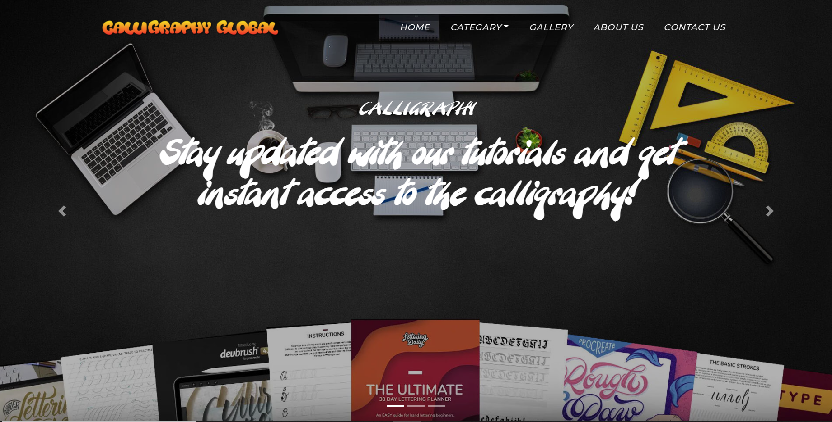

* 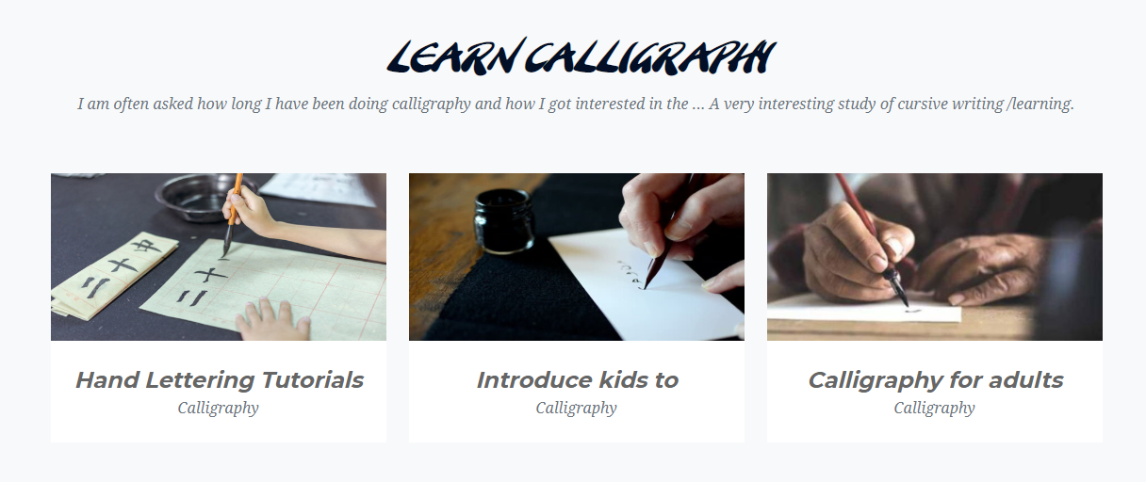Calligraphy Design :

*FPT-APTECH – T1.2011.M0. – Group 2*

16

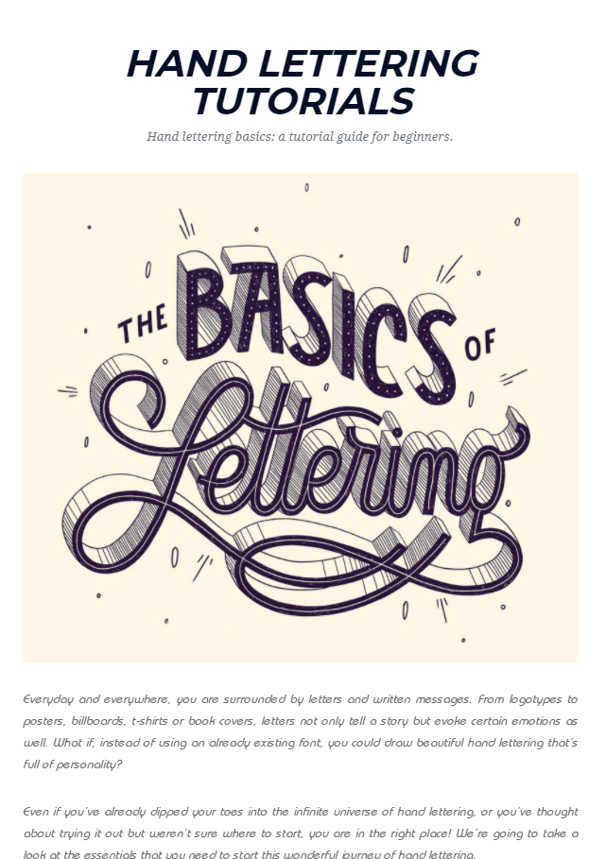

*FPT-APTECH – T1.2011.M0. – Group 2*

17

* Western calligraphy

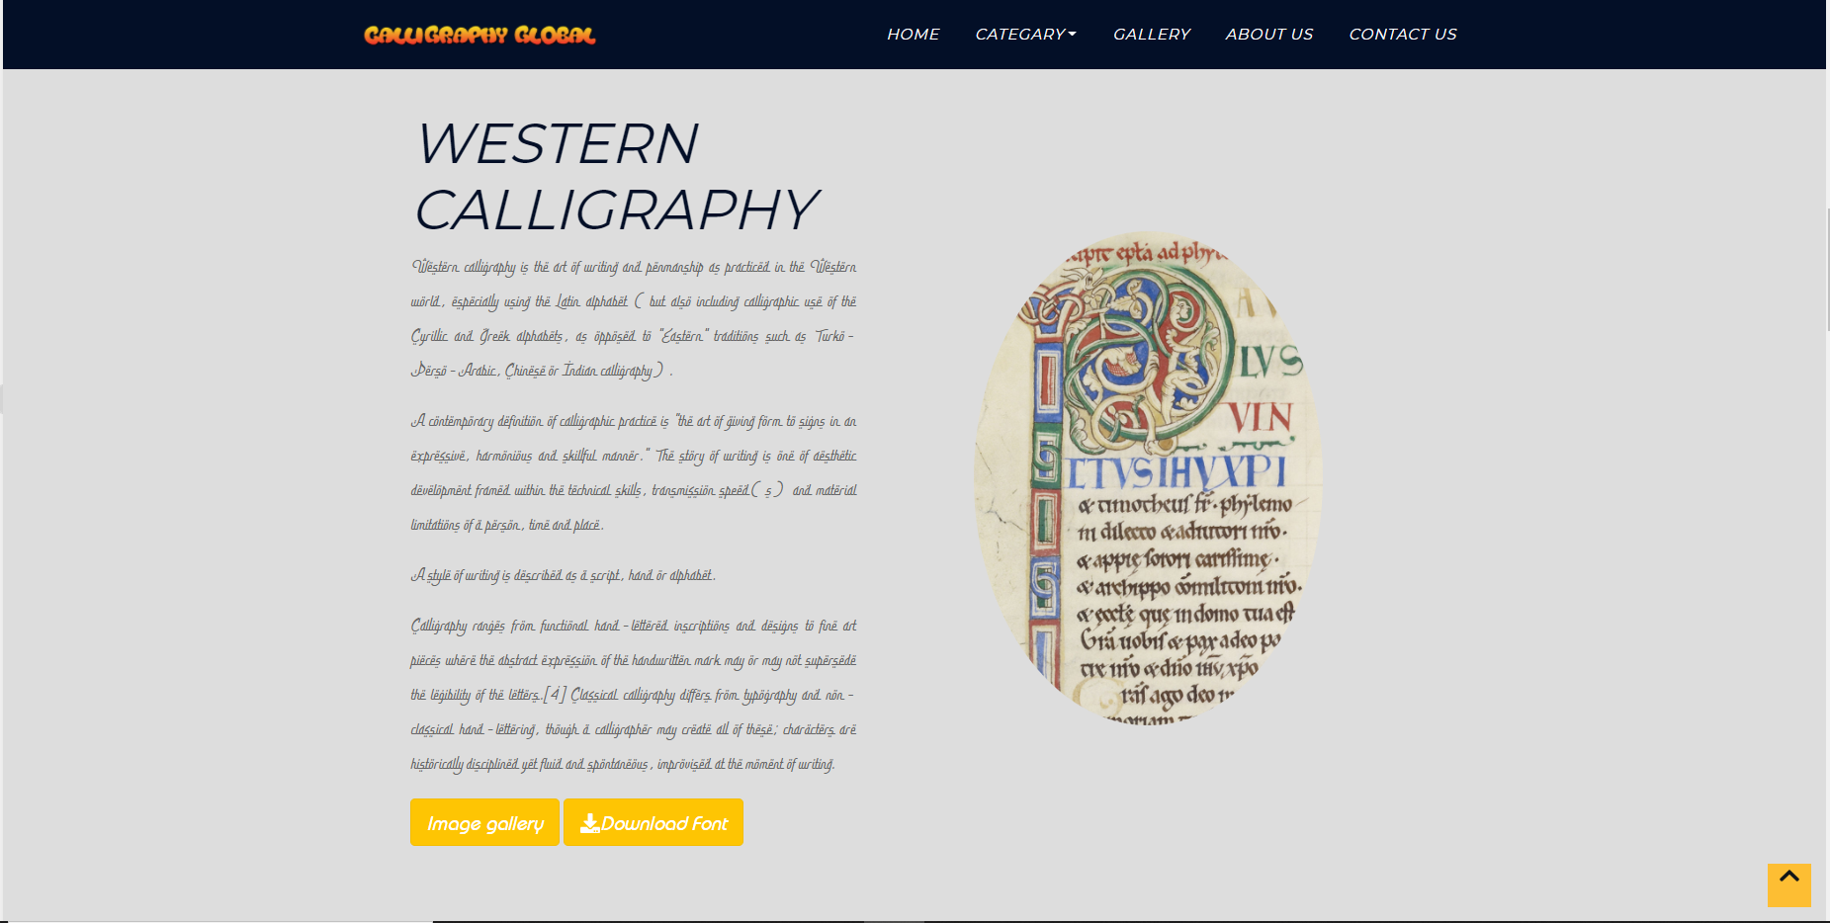

* Oriental calligraphy

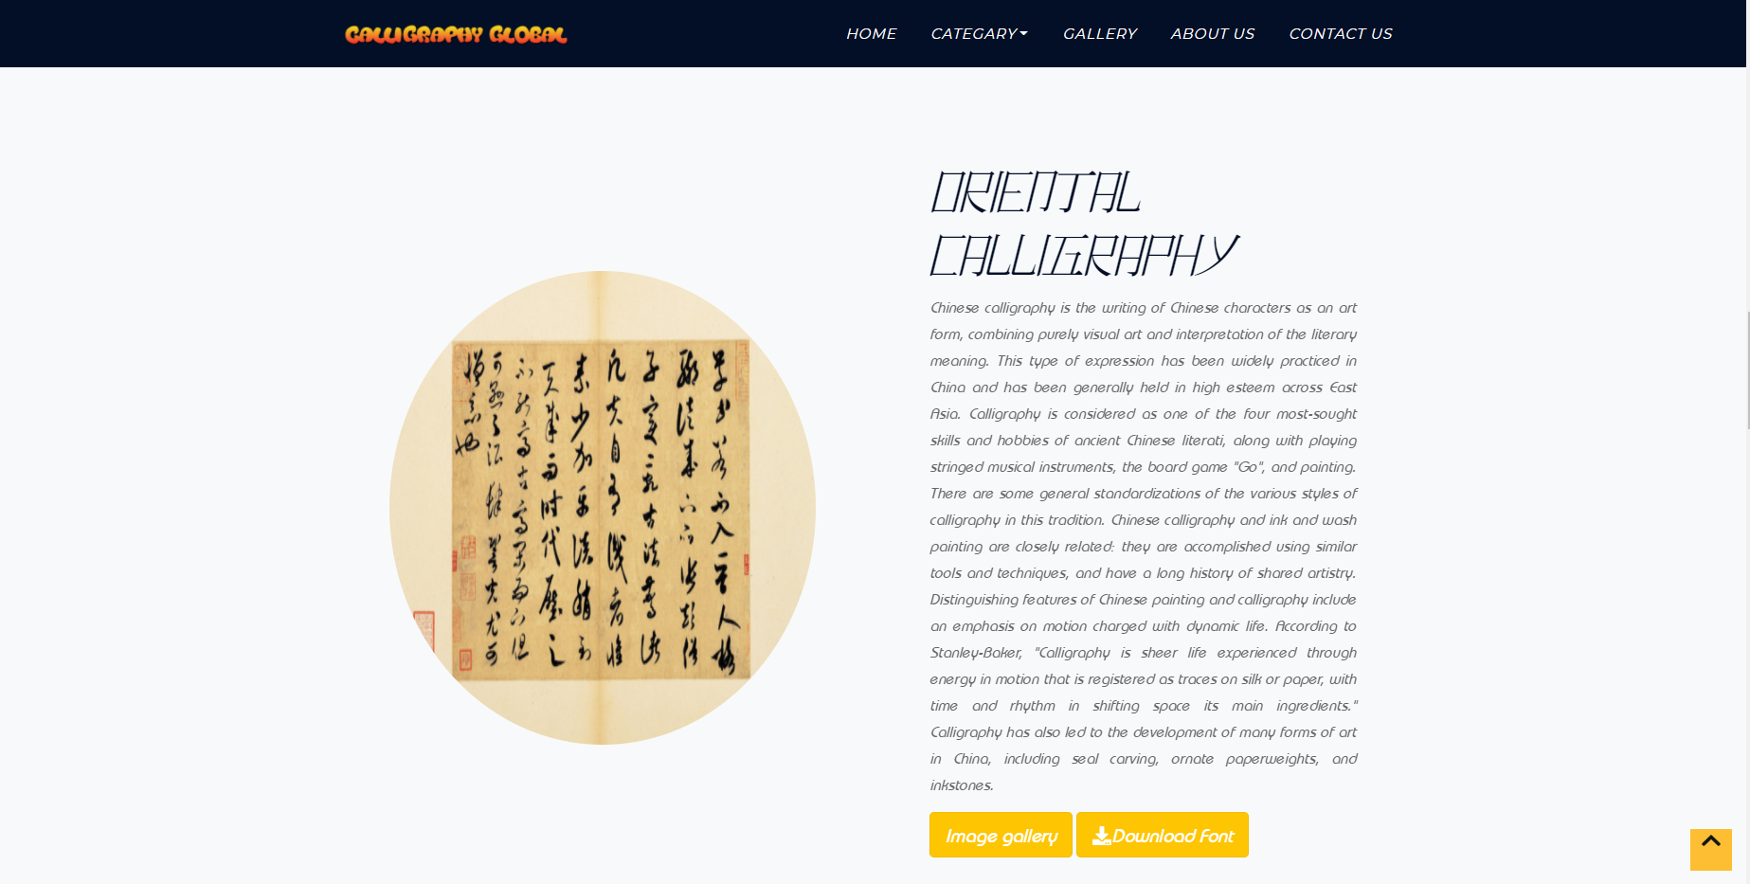

18

*FPT-APTECH – T1.2011.M0. – Group 2*

* Indian calligraphy:

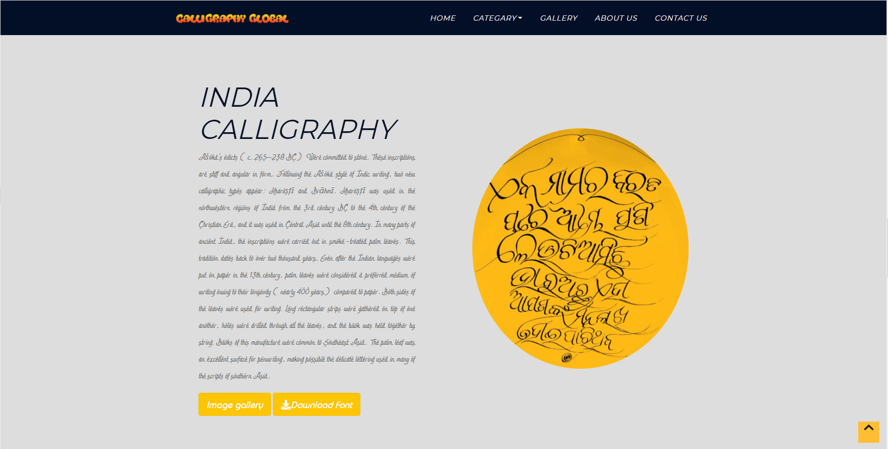

19

*FPT-APTECH – T1.2011.M0. – Group 2*

1. **About us:**

* Description:
* This page displays member of group and teachet in charge of project
* Screen shot:

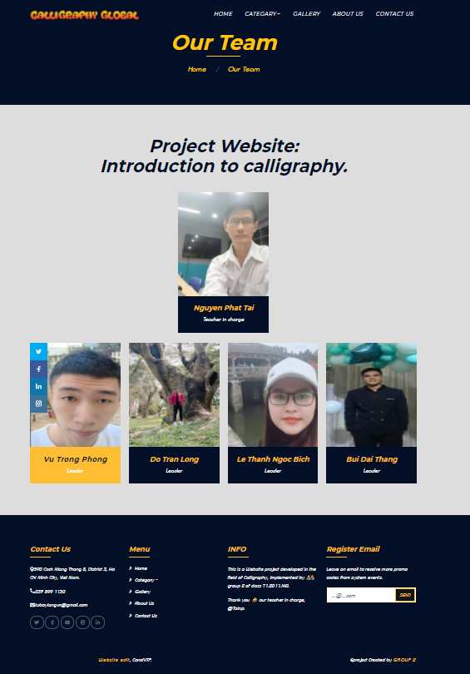

**20**

*FPT-APTECH – T1.2011.M0. – Group 2*

21

*FPT-APTECH – T1.2011.M0. – Group 2*

1. **Contact us:**

* Description:
* This page displays contact information: location, feedback, telephone number, email and a quick contact form for customer.
* Screen shot:

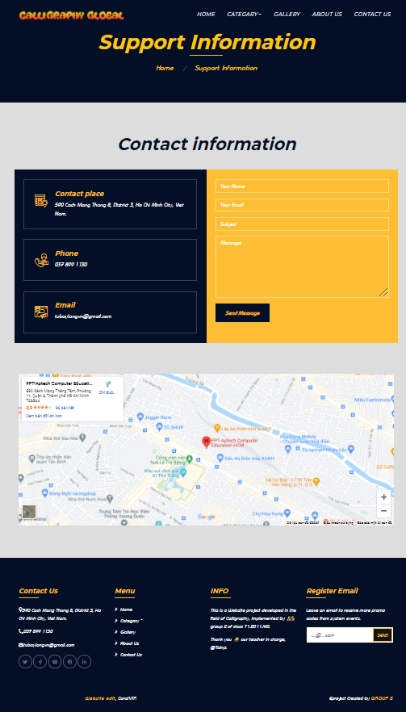

**4. GALLERY**

* Description:
* This page displays images of calligraphy styles
* Screen shot:

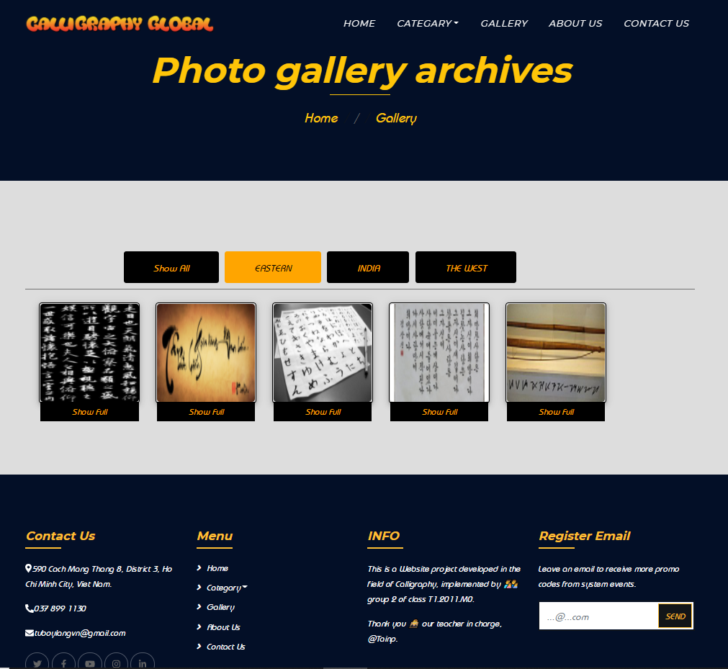

*FPT-APTECH – T1.2011.M0. – Group 2*

22

**HTML, CSS, BOOTSTRAP JAVASCRIPT DESCRIPTION**

* **This html and bootstrap to create the header for the home page navbar:**

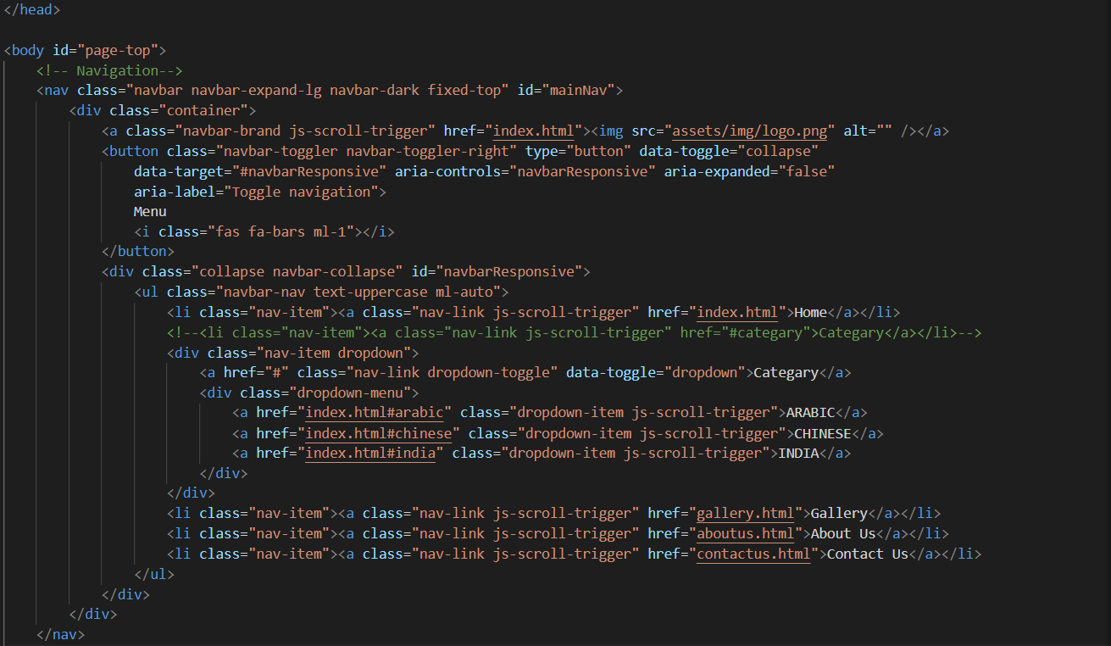

**Contact Us:**

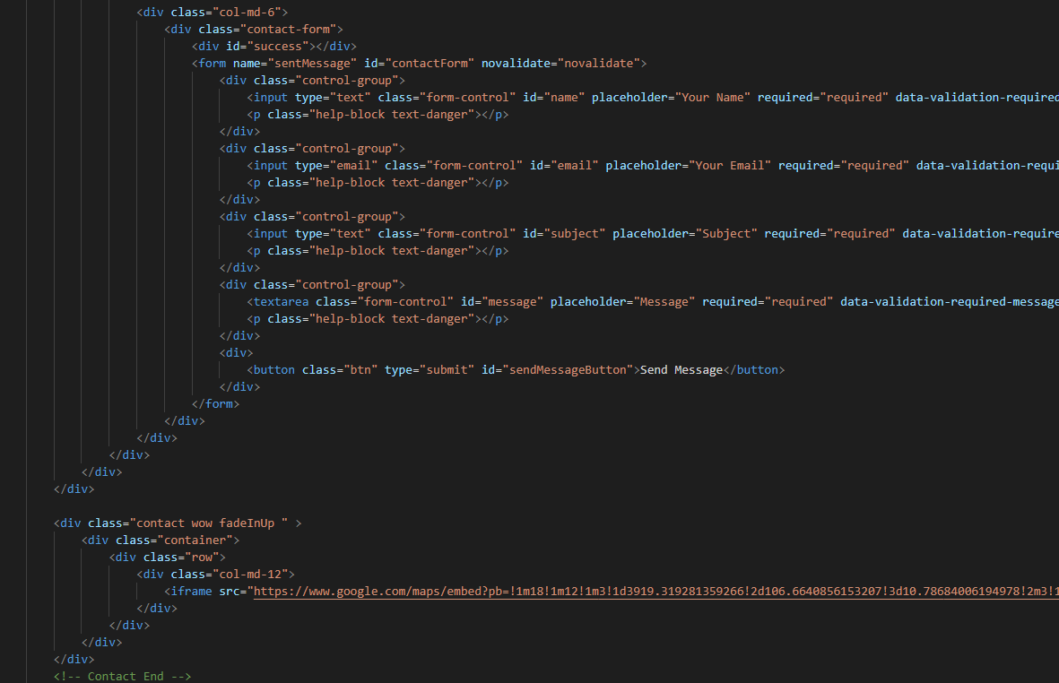

*FPT-APTECH – T1.2011.M0. – Group 2*

**23**

* **About Us:**

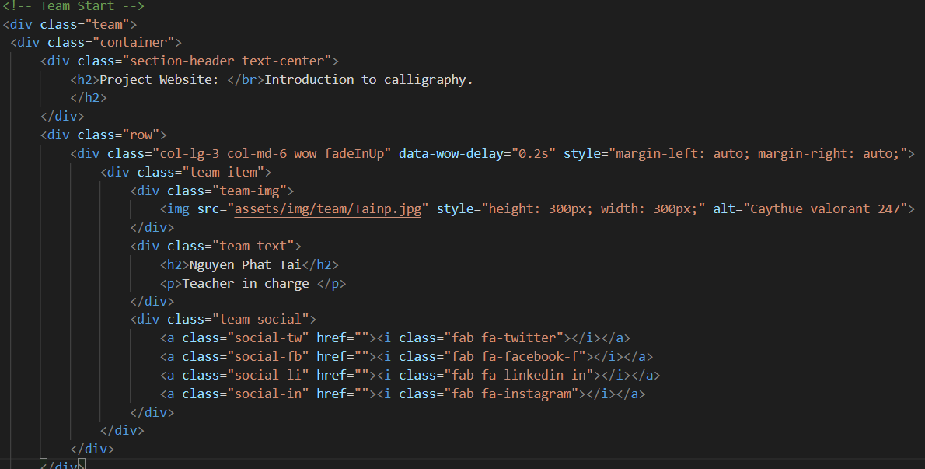

* ***Category:***

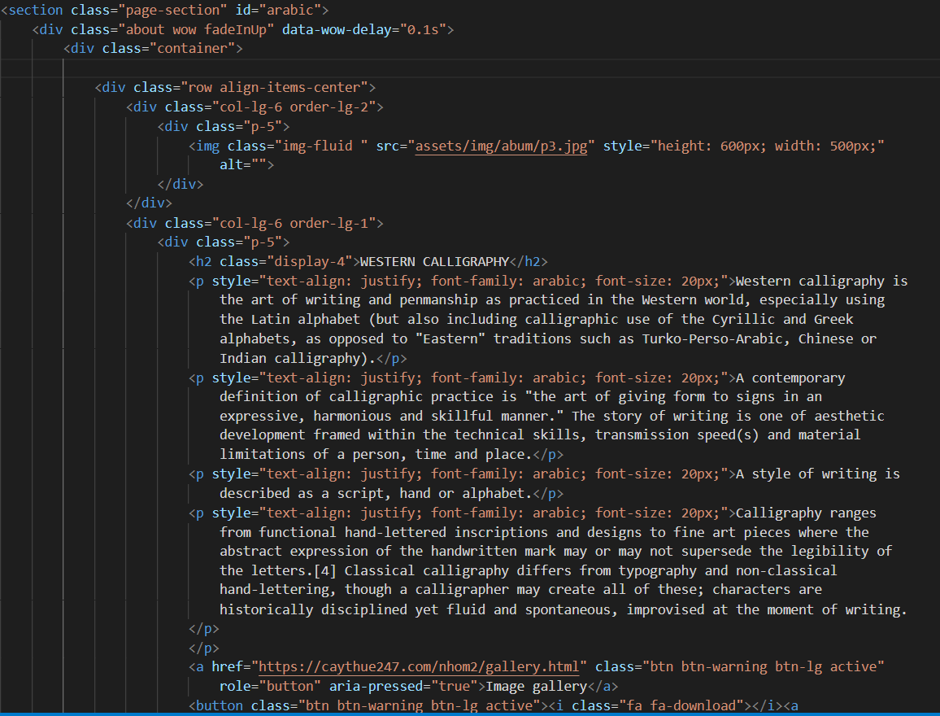

**24**

*FPT-APTECH – T1.2011.M0. – Group 2*

* **This css to create style for the Gallery:**

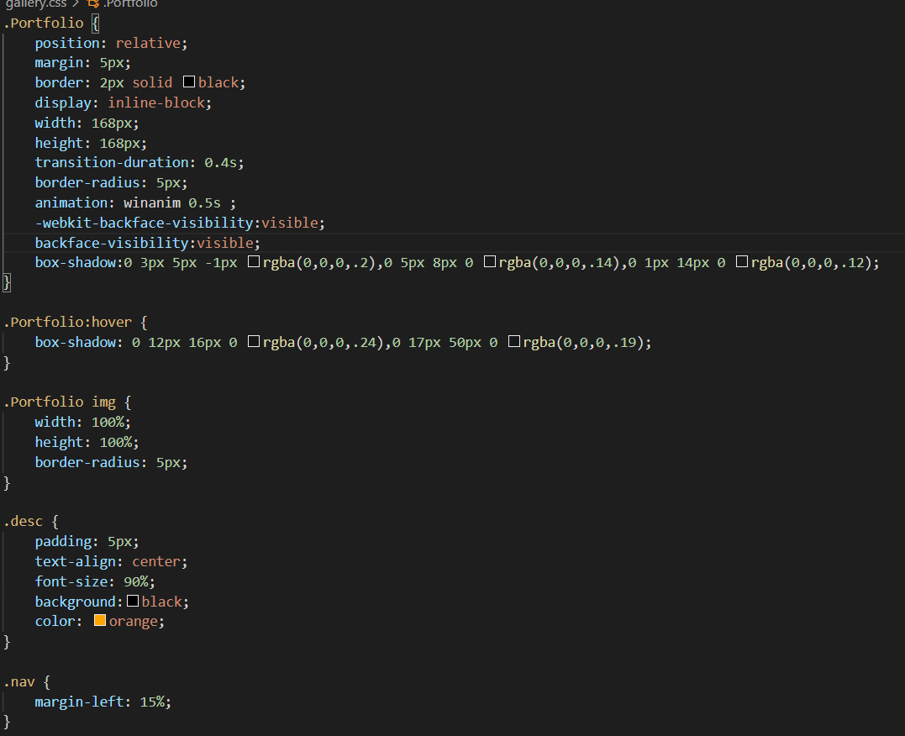

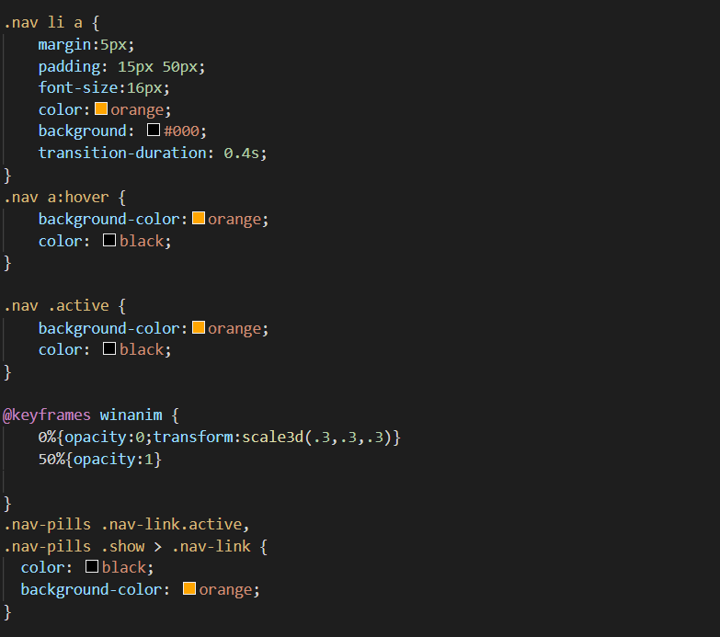

**25**

*FPT-APTECH – T1.2011.M0. – Group 2*

* **This script to create popup image.**

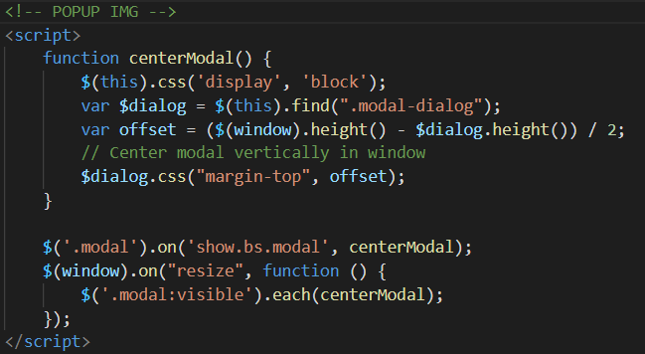

26

*FPT-APTECH – T1.2011.M0. – Group 2*

# **TASK SHEET REVIEW 3**

|  |  |  |  |  |  |  |  |
| --- | --- | --- | --- | --- | --- | --- | --- |
| ***Project Ref. No.:***  ***eP/Advertisement Portal Management System/01*** | | ***Project Title:*** | ***Activity Plan Prepared By:*** | ***Date of Preparation of Activity Plan:*** | | | |
| ***Sr.***  ***No.*** | ***Task*** | ***Actual Start***  ***Date*** | ***Actual Days*** | ***Team Mate***  ***Names*** | ***Status*** |
| *1* | *Home page (navigation bar)* | **CALLIGRAPHY** | **Phong** | 17-Mar-21 | *1* | *Phong* | *Completed* |
| *2* | *Contact Us* | 17-Mar-21 | *1* | *Long* | *Completed* |
| *3* | *About us* | 17-Mar-21 | *1* | *Bich* | *Completed* |
| *4* | *Category* | 17-Mar-21 | *1* | *Thang* | *Completed* |
| *5* | *Gallery* | 17-Mar-21 | *1* | *Phong* | *Completed* |
| *6* | *Sitemap* | 17-Mar-21 | *1* | *Long* | *Completed* |
| *7* | *Javascript for popup img* |  |  | 17-Mar-21 | *1* | *Thang* | *Completed* |

|  |  |
| --- | --- |
| **Date: 25/3/2021** | |
| Signature of Instructor:  **Mr. Nguyen Phat Tai** | Signature of Team Leader:  **Mr. Vu Trong Phong** |

27

*FPT-APTECH – T1.2011.M0. – Group 2*

*FPT-APTECH – T1.2011.M0. – Group 2*